How to Setup Port Forwarding for F9
Model Number: F9 Question Classification: Port Forwarding
The computer can be connected to the router through the network, if the notebook also can be connected to the router through the wireless, as follows:
Wired connection:
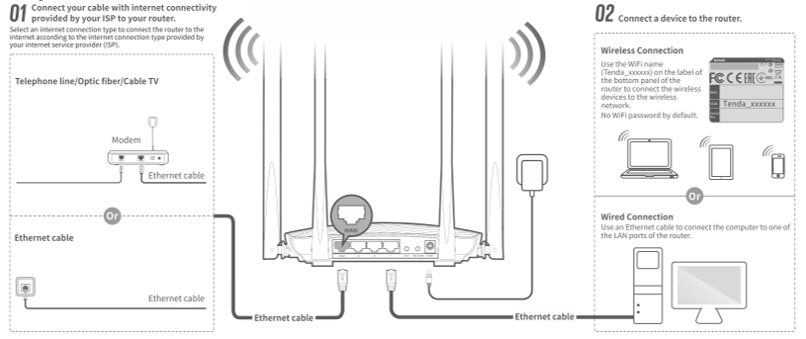
Wireless connection:
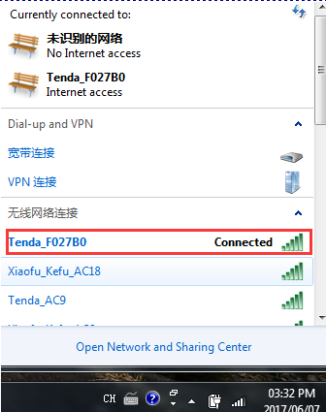

Open the browser, enter "tendawifi.com" or "192.168.0.1" log in to the router settings page in the address bar. (the factory without login password)
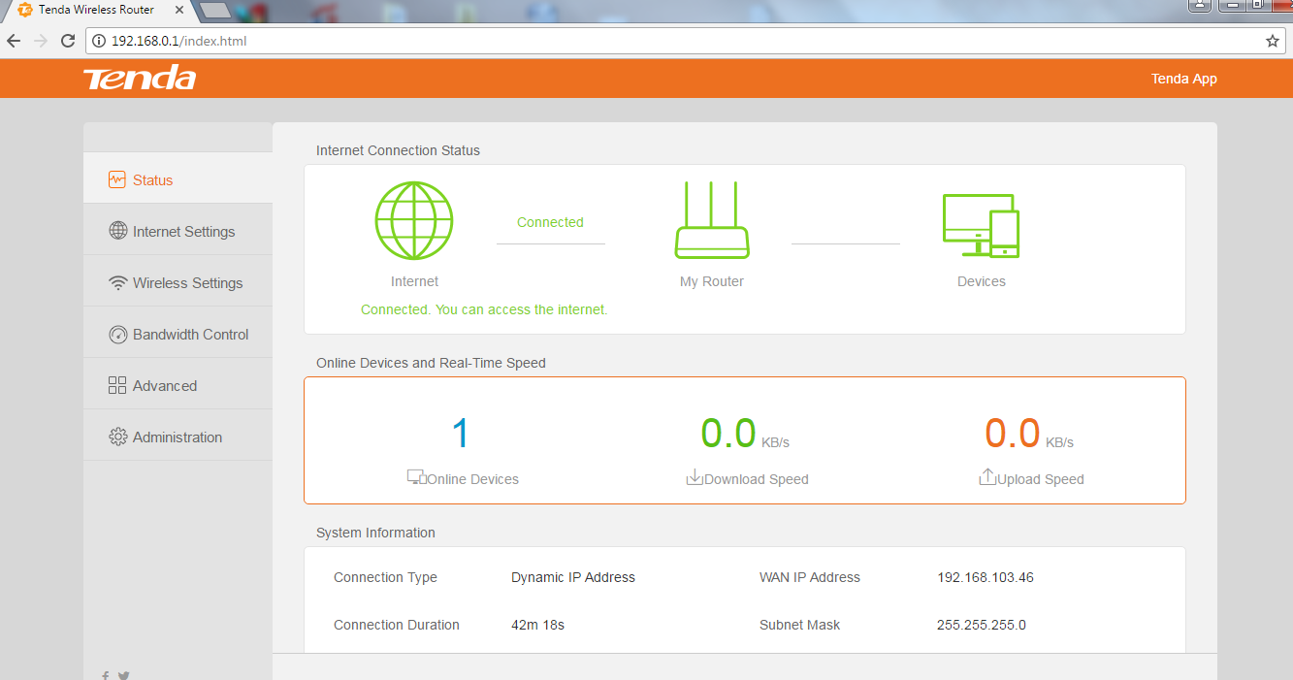

- Open the "Advanced", find "IP-MAC Binding", will require mapping computer equipment or IP, assigned a fixed IP (IP client to avoid changes to cause cannot be accessed)
2. Find the "Port Forwarding ", fill in the required mapping computer or device IP address, The port number that the internal network port needs to fill is opened by the mapped device , The port number of exterior network port you filled in can be same with the port number of the internal network port , you also can fill in different port number on the exterior network port, then click the "+" add, click "OK" button.

3. After successful setup, access method: access to equipment at the lower end of the router is accessed through mapped intranet IP and ports; device accesses from external networks (other networks) are accessed through the IP and extranet ports of the router WAN port.
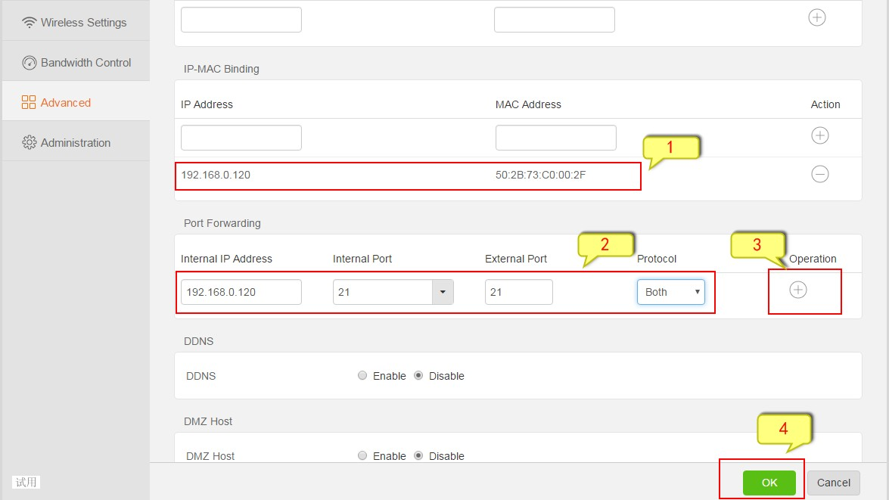

Note: Set the Port Forwarding condition is that WAN port IP of the router is to obtain public IP, judgment method : At the Baidu search bar you should enter "IP" and click "use Baidu Search" to check whether the IP address is same with the WAN port of the router address, if yes, you can use the port Forwarding function.

